# WaitStep

**Objective:**

It makes the step to wait or pause the execution for particular time which one give by user.

**Attributes:**

|  |  |
| --- | --- |
| **Attributes** | **Description** |
| seconds | Enter the seconds to wait for next step to execute |

**Sample config.json:**

{

"workflows": [

{

"name": "delete_books",

"id": 200,

"trigger": "rest",

"expression": "bookapp",

"method": "GET",

"steps": [

{

"type": "start",

"id": 1,

"next": {

"start": "1a"

}

},

{

"seconds":"8",

"type": "waitnode-step",

"id": "1a",

"next": {

"success": "1d",

"failure": "hangup"

}

},

{

"url": "https://kubernetes.io/docs/tasks/configure-pod-container/configure-pod-configmap/",

"status_code": "200",

"id": "1d",

"type": "redirect",

"next": {

"success": "hangup",

"failure": "hangup"

}

}

]

}

],

"filters": [],

"server": {},

"plugins": []

}

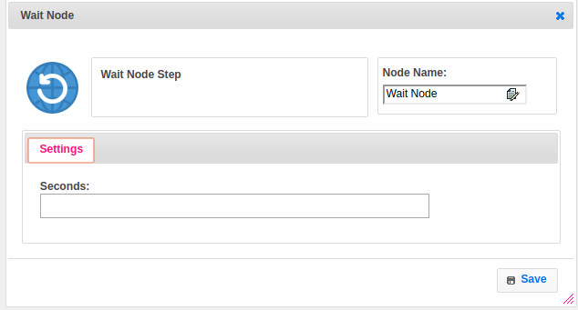

**Executor Description:**

In executor class first it converts seconds into milliseconds and then make the currently executing thread to sleep (temporarily cease execution) for particular time which one given by user.